Anxiety
What is Anxiety?
Anxiety is feelings of worry, fear and panic. As well as emotional feelings, people with anxiety can also experience physical sensations such as a racing heart, breathing fast, sweaty hands, dry mouth and feeling shaky. Many people also have “what if” or negative thoughts when they are anxious.
Is Anxiety Normal?
Anxiety is a normal human response to feeling threatened or in danger, even if that threat is a thought, image or memory. Anxiety can become a problem if it starts to stop you from doing the things that are important to you or that you once enjoyed, such as hobbies. Also, if the thoughts, feelings and physical sensations are very strong, happen even when there is no real danger or last for a long time. Remember having anxious thoughts, feelings and sensations are not dangerous.

What kind of thoughts or feelings can someone have if they are feeling anxious?
Lots of people experience worry and anxiety although for some people it can impact on everyday life and get in the way of school, college, socialising and home life. The types of anxiety that are most common include:
• Worries about what other people think of you
• Worries about being judged negatively
• Worries about bad things happening to you or the people you care about
• Uncontrollable constant worry about lots of things
• Worries about your safety and health
• Phobias about specific things
• Worries that you are responsible for bad things happening
• Feeling the need to complete certain routines, rituals or behaviours to stop bad things from happening (commonly known as Obsessive Compulsive Disorder)
What should a young person do if they are experiencing anxiety?
Tell someone how they are feeling, no matter what their worries are. This can be anyone who they feel comfortable talking to about it. It could be a parent, a friend, a sibling, a teacher or their GP.

How can a young person manage anxiety?
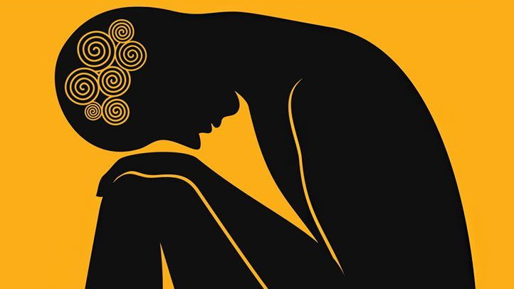
They can try using activities that they enjoy, such as watching TV, spending time with friends, reading or listening to music.

