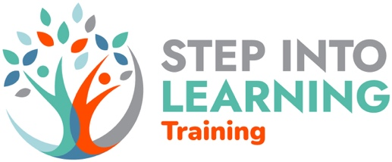
Level 3 & 4 Counselling
Application Form

PERSONAL INFORMATION |  |  | Title | Choose an item.
First Name(s):
Surname:
Address
 | Postcode:
Telephone | Home |  |  |  | Mobile
Email:
Date of Birth: | Click or tap to enter a date.

Course Information
Which course do you want to study? |  |  |  |  | Choose an item.
Full-time | ☐ | Part-time | ☐ |  |  | Course location |  | Choose an item.
How did you hear about this course? |  |  |  | Step into Learning website |  |  | ☐
 |  |  |  | Social media |  |  | ☐
 |  |  |  | Word of mouth |  |  | ☐
 |  |  |  | Advertising |  |  | ☐
 |  |  |  | Other

EDUCATION
Level | Subject | Grade achieved | Date achieved
GCSE | Maths | D | June 2019

Do you have any support needs? Choose an item.
If you answered yes, please select all that apply

Mental ill health | ☐ | ADHD | ☐
Emotional/behavioural difficulties | ☐ | Disability affecting mobility | ☐
Asperger syndrome/ASD | ☐ | Medical condition (asthma, epilepsy,  diabetes, allergy) | ☐
Visual impairment | ☐ | Multiple disabilities | ☐
Hearing impairment | ☐ | Dyslexia/Dyspraxia | ☐
Other

Personal statement

In the space below please tell us:
- why you want to do this course? Is this for eventual employment as a counsellor or mainly for self-development?
- what challenges do you think you will face doing this course?
- your current circumstances e.g family, work
- What steps do you put in place to take care of your emotional needs?
- Have you had experience of counselling? Yes/No
If yes:
- What model of therapy?
- How recent was this
- Say why you feel you are academically & emotionally able to cope with this level of training
- Would you say you are able to give and receive feedback constructively?

Write a minimum of 500 words

